Network Task
1.Get me the IP address of a particular domain (guvi.in). How do I find my CPU/memory usage of my server?. Test the connectivity between 2 nodes?
Get me the IP address of a particular domain (guvi.in)
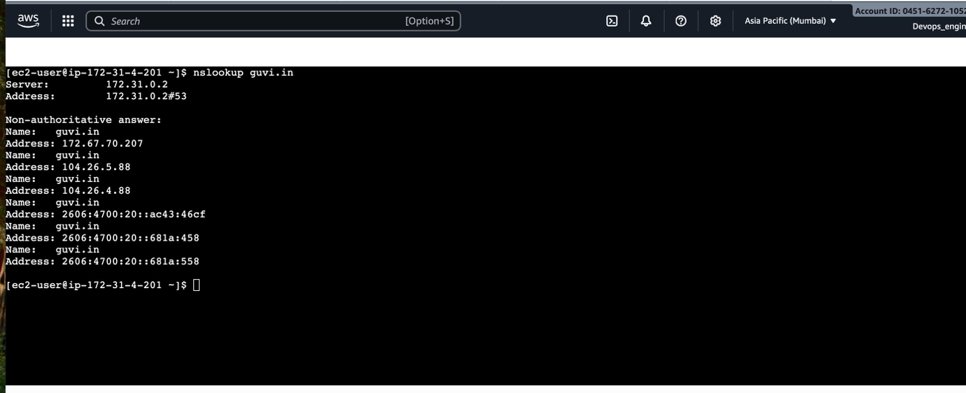
How do I find my CPU/memory usage of my server?
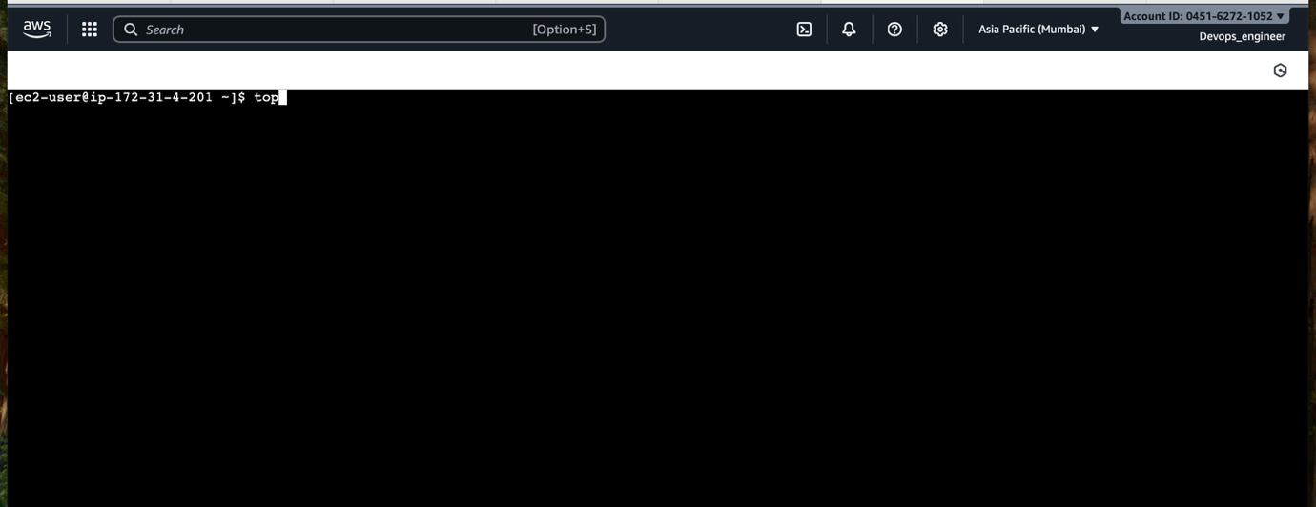
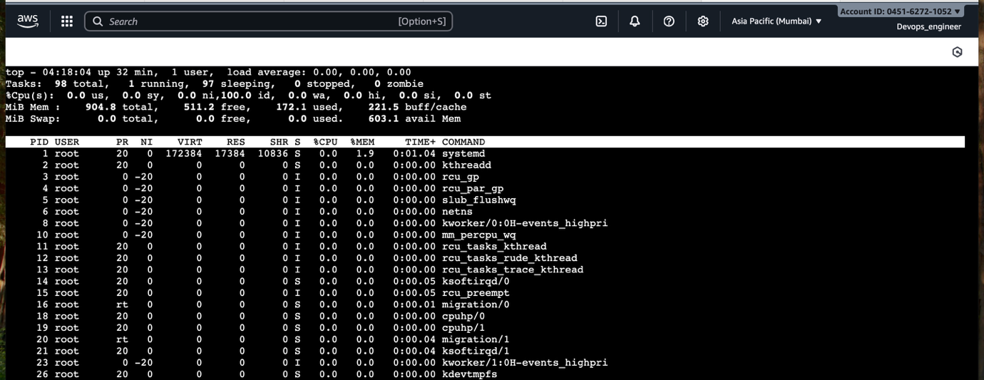

Test the connectivity between 2 nodes?
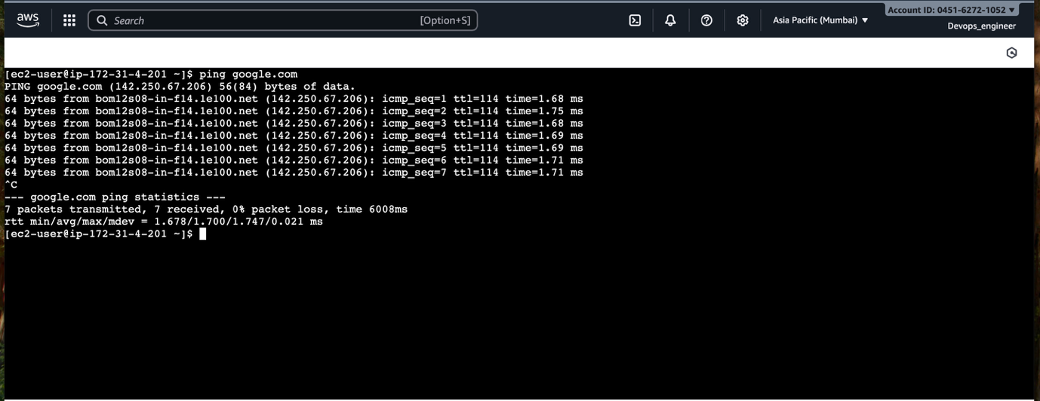

2.I have deployed an application in guvi.com:9000, and logs show my app is running, but I’m unable to view the page. Check whether my port is open or not ?

Added the inbound rule for allowing port 9000
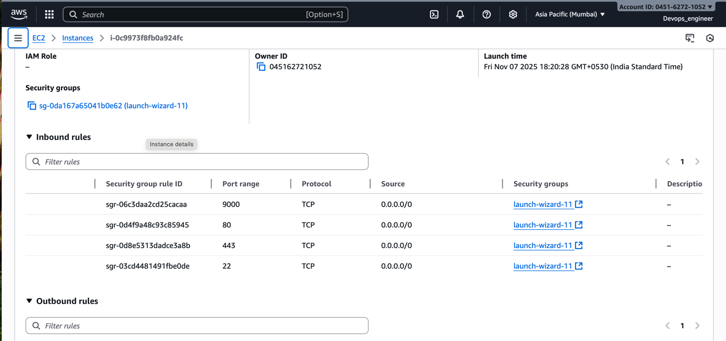

Checking Listening Ports Inside EC2
Only port 22 (SSH) is open.
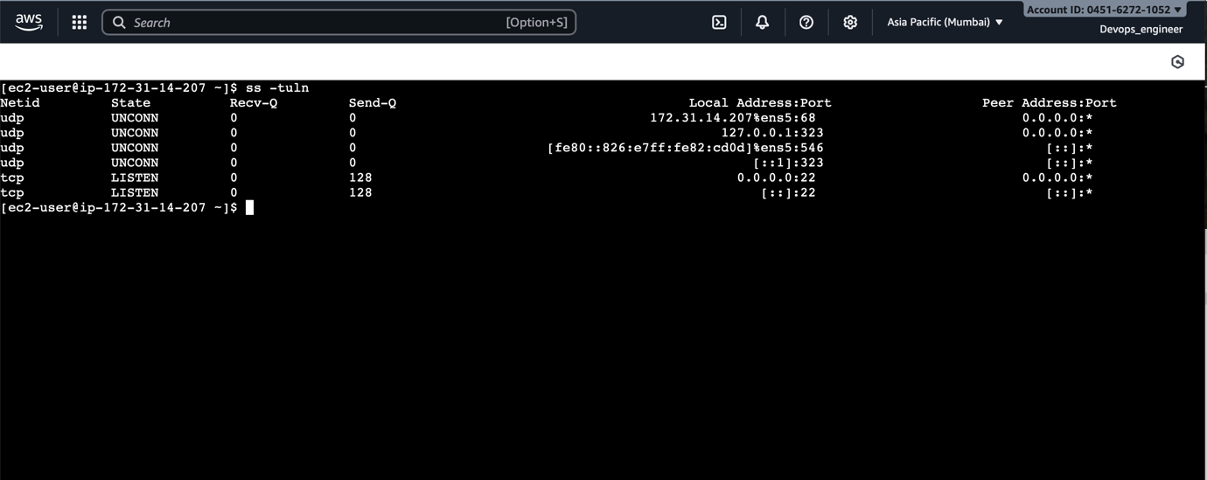

Testing connectivity to a specific port

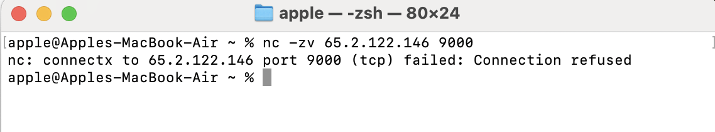

Result:

Port 9000 is not open.

